Lab Report for Module 5 Dropbox

Lab: Safe Browsing

Submitted by: Tristan Izlar

1. 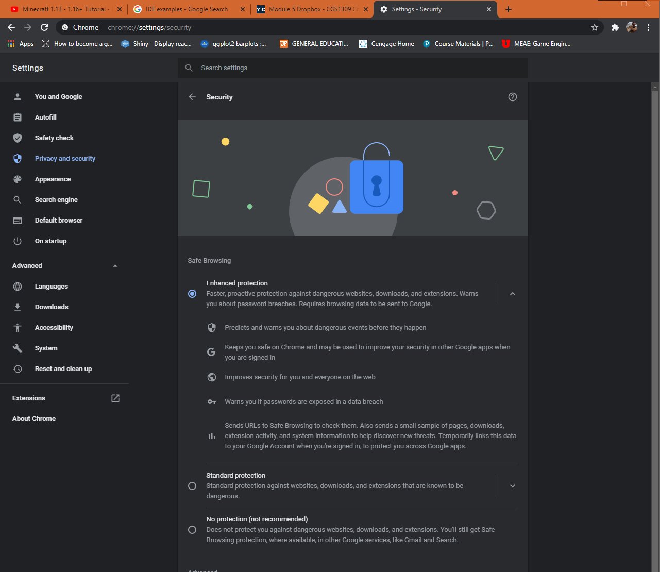
2. 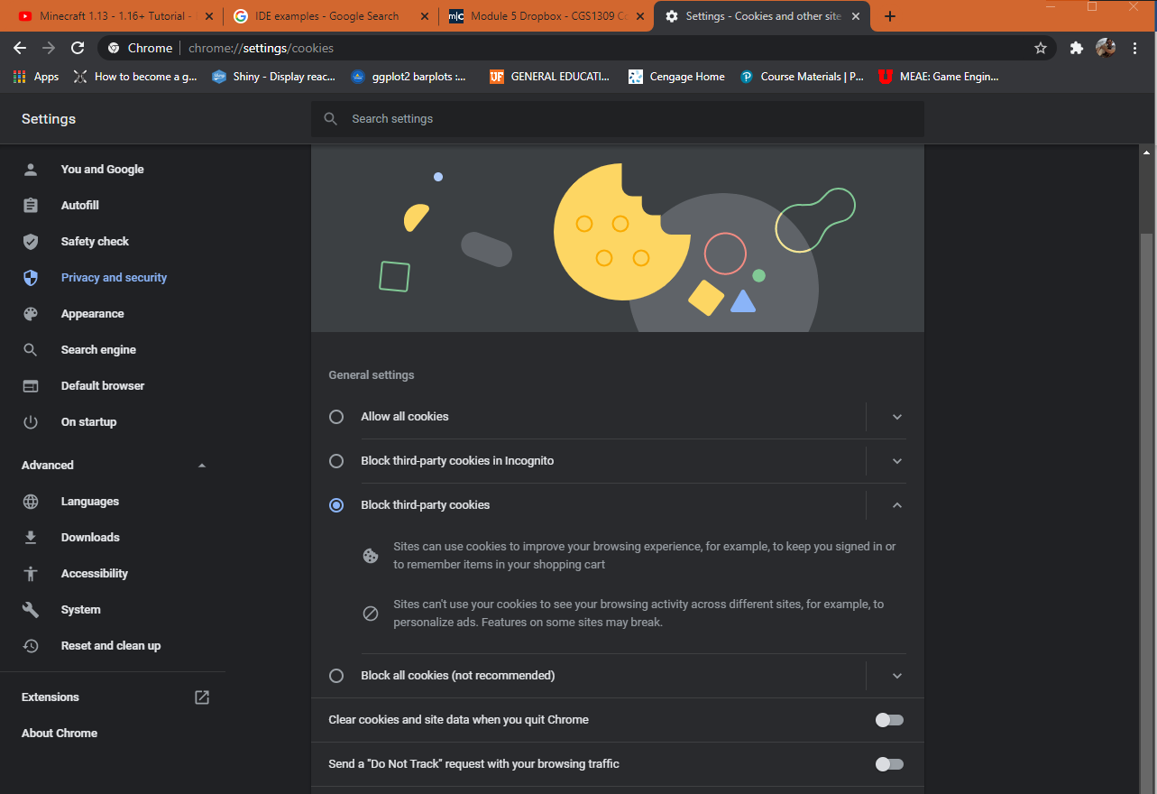
3. 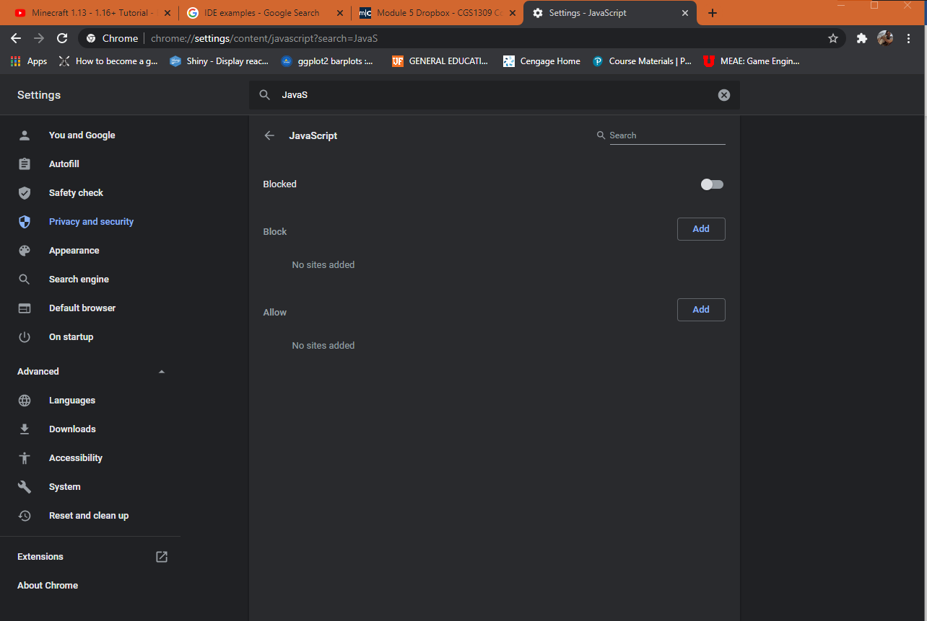
4. The most recent version of chrome doesn’t have plug in settings in the settings area. I’m sorry I wasn’t able to provide a screen shot for this!!!
5. 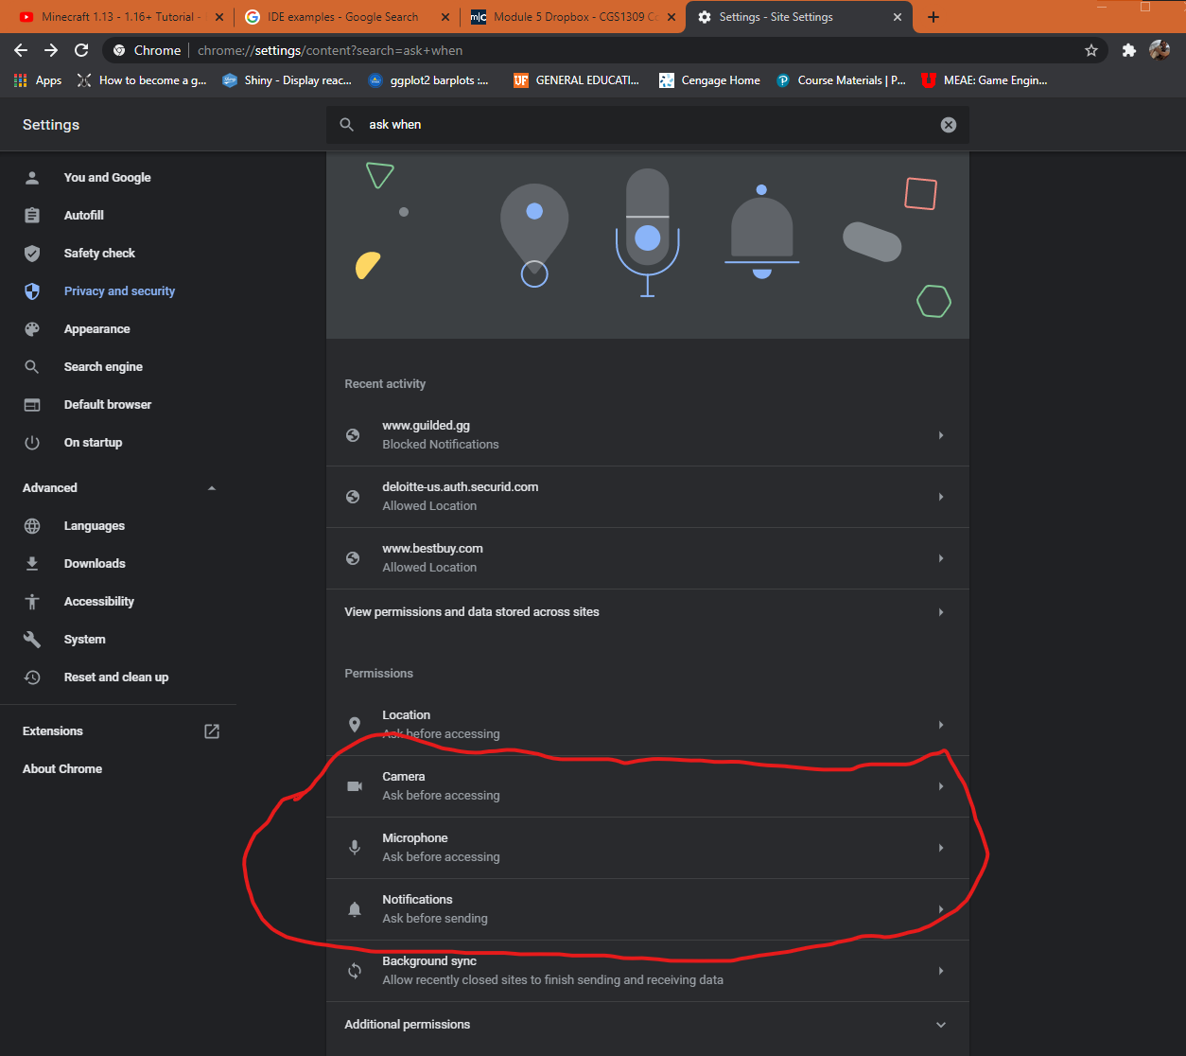
6. 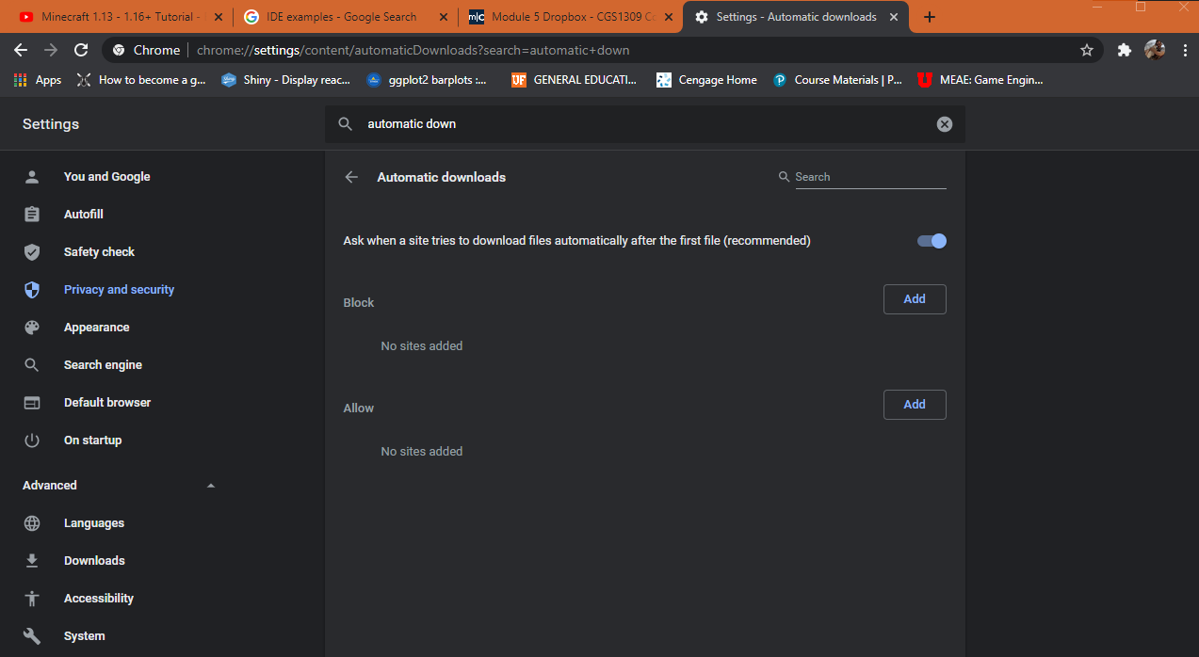
7. 